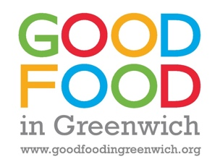
Top tips to shop more effectively
Eating well can help us feel our best and make a big difference to our long-term health. However, an estimated 1 in 10 people in the UK say that they are struggling to get enough food to eat. This is about 22,000 adults in Greenwich. A large number of children will also be affected.
Do you worry that you, your family or friends will have enough to eat?
If you or people you know are affected by this situation a number of organisations and services providing support in Greenwich are listed here. Read further to find top tips for shopping cost effectively.
Top tips to make shopping cost-effectively easier:
- The average family with children in the UK throws away about £60 of food a month. Plan meals before shopping and check what you already have, so you only buy what you need and reduce food waste.
- Make a shopping list and stick to it.
- Supermarket’s ‘own brands’ and ‘value’ ranges are usually as good as more expensive, branded products. You could save £1,500 a year on food by buying these.
- Don’t be tempted by special offers on things you don’t need, as this will mean you spend more. You may also find special offer items aren’t as good value for money as the same items in the ‘value’ range for example.
- Shop around to find better deals. If you can get to a market, these are a great source of reasonably priced fruit and veg.
- Attend a Community Cookery Club to find out how to cook at home using basic ingredients. This is cheaper and healthier than buying ready-meals and takeaways.
- Save your leftovers for lunch the next day.

